CI CD LAB EXPERIMENT-4

(BY: AMAN TYAGI)

Aim: Static Code analysis using SonarQube

1. Download SonarQube community edition from <https://www.sonarqube.org/downloads/>
2. Extract the downloaded file
3. In the extracted folder go to bin, and then to Windows-x86-32 (according to Windows OS) to find a file named StartSonar.bat

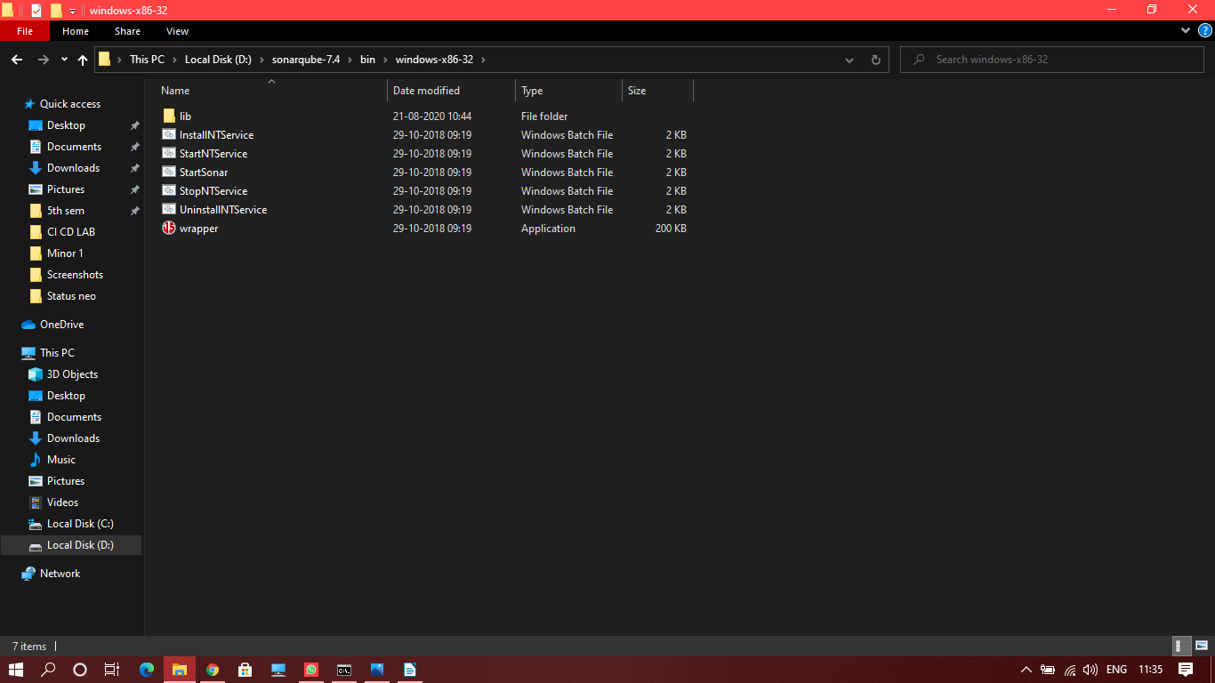

1. Open command prompt as admin and move to the folder where the StartSonar.bat file is stored.
2. Run the command

StartSonar.bat

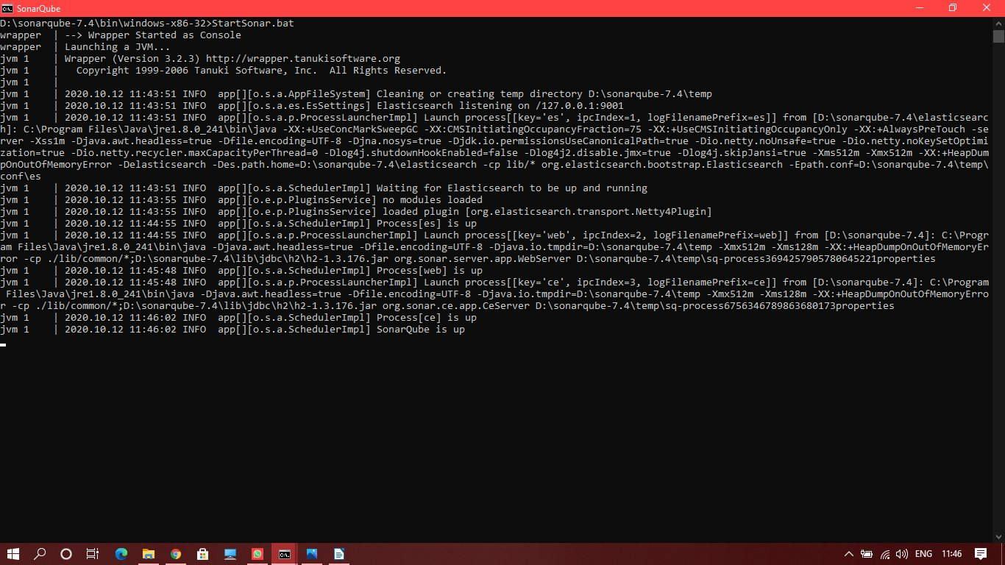

1. Once the command successfully runs, go to localhost:9000 (Default port for sonar)

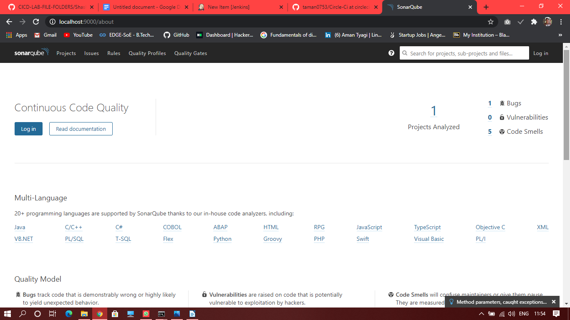

1. Now from another command prompt window traverse to the project for which analysis is to be run
2. Run the command

mvn clean install sonar:sonar -Dsonar.host.url=http://localhost:9000 -Dsonar.analysis.mode=publish

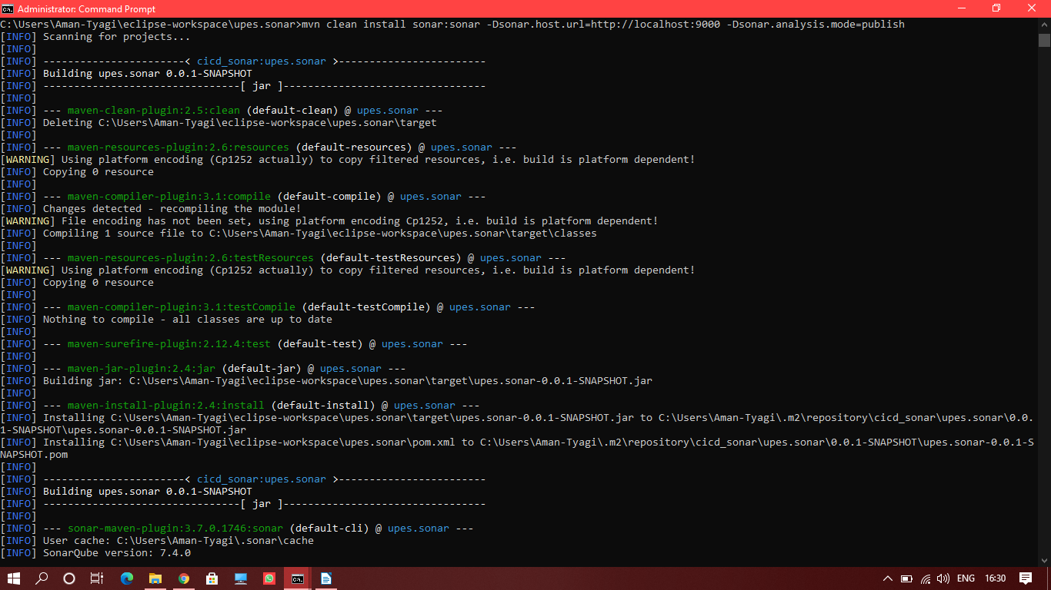

1. You will get “Build success”
2. Navigate to the project tab at SonarQube dashboard , and you will see the analyzed project.

